# CS-600-A Homework 9

Zijing Huang 10414952

**R-20.7 Consider an initially empty memory cache consisting of four pages. How many page misses does the LRU algorithm incur on the following page-request sequence?  (2,3,4,1,2,5,1,3,5,4,1,2,3)**

First of all, let me describe the model of memory cache to make clear what the question requires us to do.

As we known, most virtual memory system use a technology called paging, which create a mapping relationship between virtual memory and physical memory. The advantage is we can get a larger memory space(even an infinite memory). The disadvantage is we must pay an extra transfer time when the data we need is in different pages. To lower this cost, we can cache some page that we usually use. When we need to get a page from disk, we check if the page is in the cache first. If yes, we get the page from cache. If no, we get the page from disk, and put a copy of it into cache. If the cache is full, according to the LRU algorithm, we kick off the least-recent-use one.

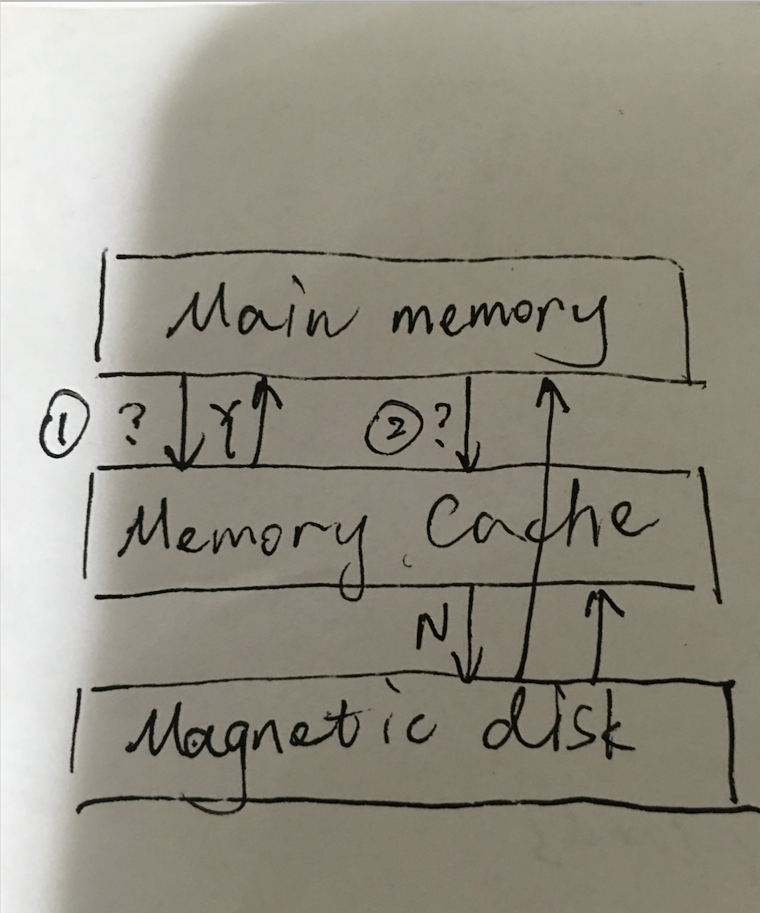

For this question, the capacity of the cache is 4 pages. Which means we can mostly store 4 pages into the cache. If we are going to add the 5th page, the most least-recent-use page in the cache will be removed. And then we can use a weight to represent the status of the usage of a page. Intuitively, the more usage of a page, the larger weight it has. So each time we put a page into cache, we update its weight to an maximum number so far which can be the round number.

In this question, we have 13 rounds. For the round 0, we initialize the main memory, the cache and the disk.

For each round, we first check if the page that we are looking for is in the cache. If yes, we just get it from cache and update its weight in cache as the round number. If no, we get it from disk and insert a copy of it into cache. If the cache is full this time, we remove the page with the lowest weight. Finally, we update the weight of the page that we are looking for in the cache.

The detail is as follows:

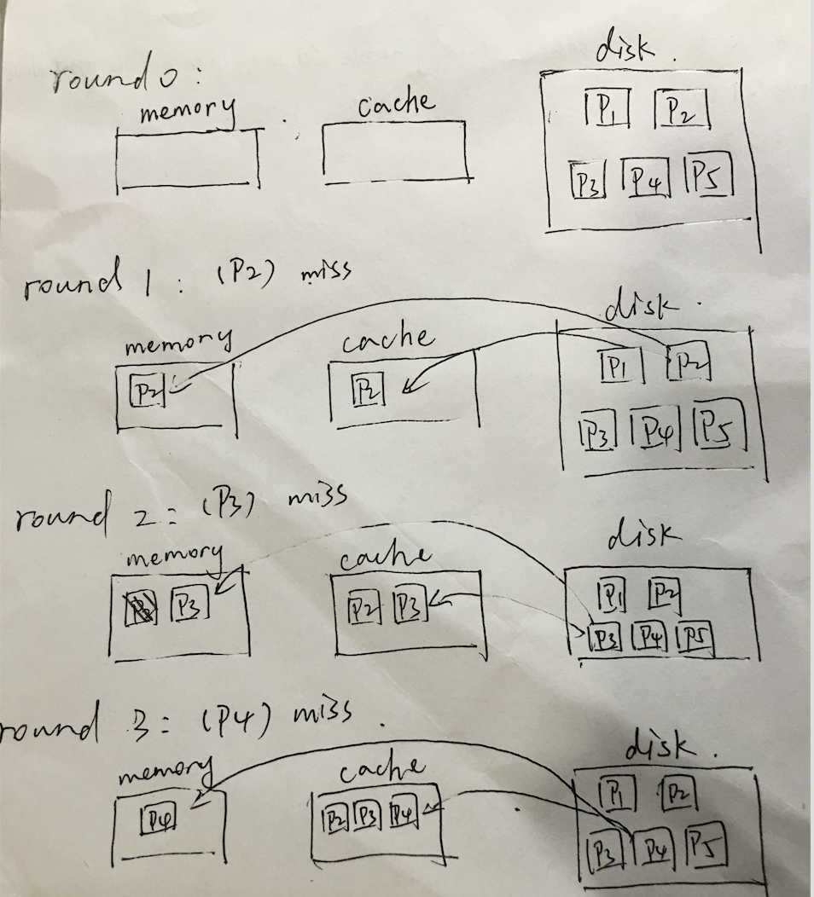

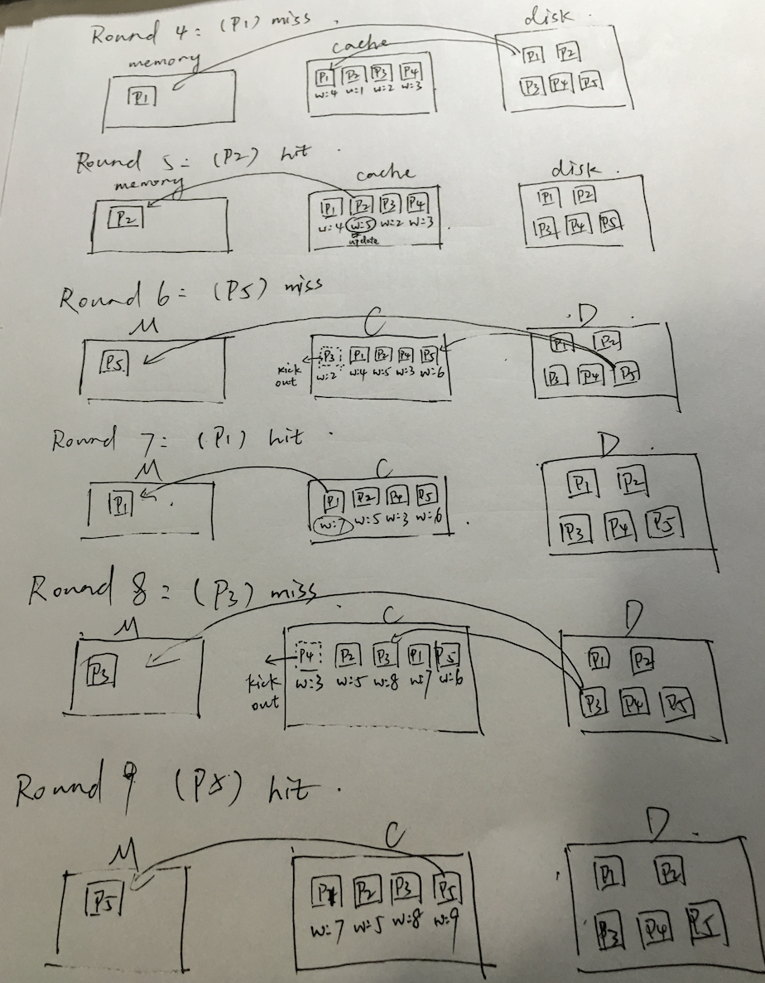

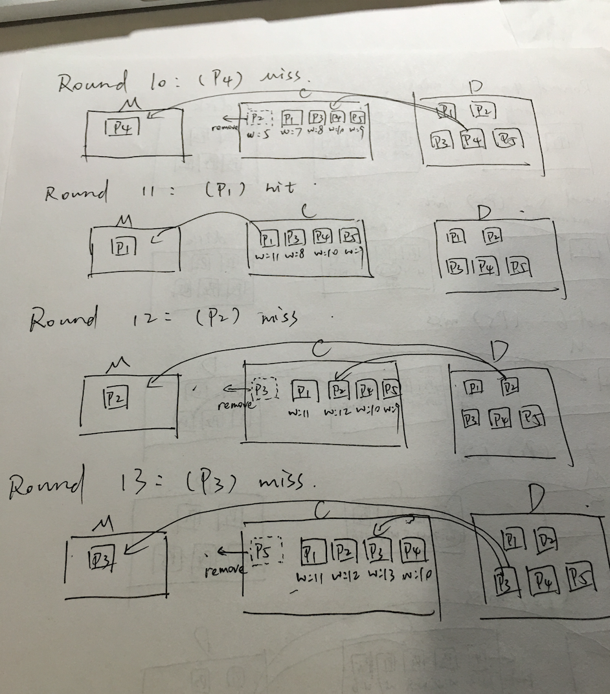

Therefore we miss 9 times in this page-request sequence.

**C-20.1 Show how to implement a dictionary in external memory, using an unordered sequence so that insertions require only O(1) transfers and searches require O(n/B) transfers in the worst case, where n is the number of elements and B is the number of list nodes that can fit into a disk block.**

First of all, we can usually use an array, a hash or a linked list to implement a dictionary. But I will tell you why we don’t use array and hash in this case. With the size of an array or hash bucket increasing, the transfers of the insertions of an array or hash increase too(can’t put all the array or hash into memory). But if we use linked list, we can always do an insertion in O(1) time by sending the tail node of the linked list from disk to memory. To reach the highest performance, we usually give a node the space of a block of size B. So we can get the tail node in memory in 1 transfer. And then we check if the tail node is full. If yes, we create a new node as tail node and add the new item into it. If no, we directly add the new item to the tail node.

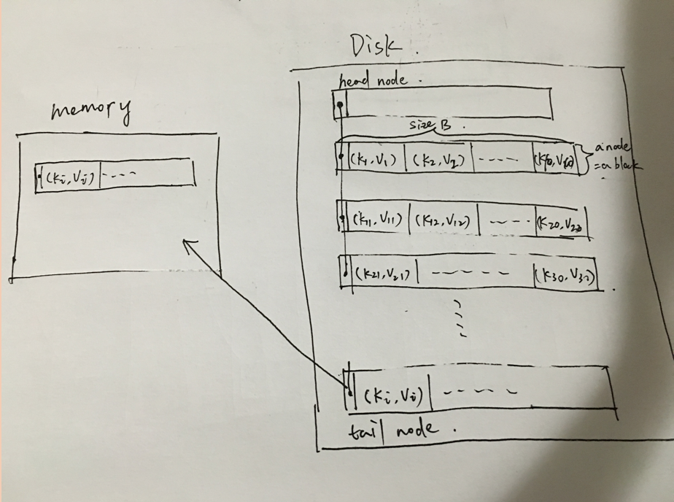

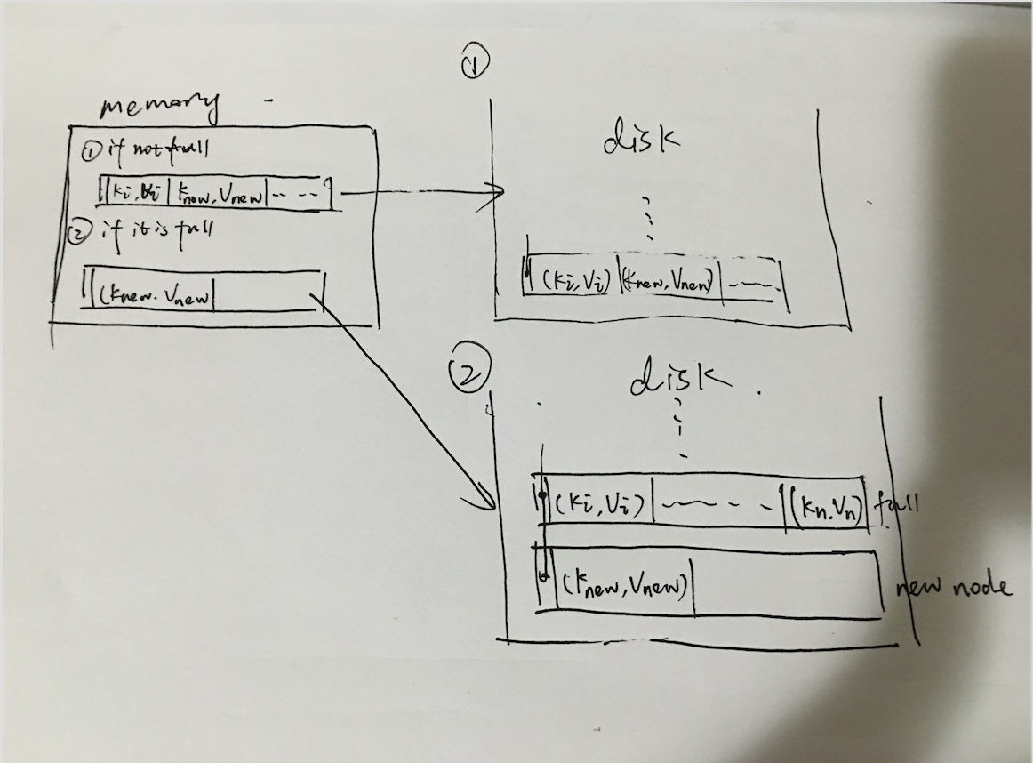

Assume that the capacity of memory is 1 block for input. In order to search the target (key,value) in the disk, each time we transfer a node of linked list from the disk to the memory. If we don’t find the target in the current node, we transfer the next node to the memory. The worst case happened when the target value is in the tail node of the linked list, which cost O(n/B), B is the size of a block.

**A-20.4 In the MapReduce framework, for performing a parallel computation, a crucial step involves an input that consists of a set of n key-value pairs, (k, v), for which we need to collect each subset of key-value pairs that have the same key, k, into a single file. Describe an efficient external-memory algorithm for constructing all such files. How many disk transfers does your algorithm perform?**

The brute force method is to get a block of sets of n pairs and compare to each file to see if this pair belong to this file. And then get the next block of sets and repeat the process above. Let’s assume each block contains B key-value pairs. The total transfers would be n*m + n/B, m is the number of file. It is not efficient.

So, what if we can first sort all the set and then do a linear scan. We put all the key to the same file until we reach a different key from the previous key, we create a file and do the same process above. Now what we consider is how to do an external sort. We can use external merge sort this time. The total transfer time would be *b ( 2* ⎡log*M*–1(*b / M)*⎤ + 1). b denotes the number of blocks containing of the sets. M denotes how many blocks the memory contains. (reference: Database System concept 5th edition, Chapter 13).

**R-23.12 Give an example of an input instance for lexicon matching problem, with just a single pattern in the lexicon, L, that forces the Karp-Rabin algorithm given in Algorithm 23.11 to run in Ω(nm) time.**

First of all, as we known, compute the hash value of a length-m substring of T, takes O(m) time; hence, computing all the hash values for the length-m substrings in T takes O(nm) time. So, the first step doesn’t reach Ω(nm) time.

So we continue looking at the second step, we compare the hash of the substring in text with and the hash of the only pattern, which takes n-m times. If the value of the hash is match, we further on comparing each letters between the substring of the text and the pattern, which is in order to make sure the matching hash is not by a collision. This comparison takes O(m). So there is only one possible situation to force the Karp-Rabin algorithm running in Ω(nm) time. That is every pair of hash value is matching and every time of the comparison is matching too. For example, if the pattern is a single string consist of any letter of length m(ex. (kkkk…k)m), the text is consist of any matching letter of length n(ex. (kkkk…k)n), the running time will be Ω(nm), because it needs to compare each letter in patter in each substring.

**C-23.4 Let T be a text of length n, and let P be a pattern of length m. Describe an O(n + m)-time method for finding the longest prefix of P that is a substring of T .**

The brute force solution is similar to Brute-Force Pattern Matching in textbook page 654. When T[i] and P[j] is not match, we have to go back to T[i+1] and j=0, repeat the above process. And we just need to record the maximum matching length. The running time of this algorithm is O(nm).

To improve the algorithm above, we only need to modify The Knuth-Morris-Pratt Algorithm a little bit. First of all, we compute a failure function f(j) which runs in O(m) time, m is the number of letters in the pattern. And then we compare the letter T[i] in text with the letter in the patter P[j]: (reference: textbook page 662)

*• If T[i] = P[j], then i increases by 1, and k does not change, since j also increases by 1.*

*• If T[i] <> P[j] and j > 0, then i does not change and k increases by at least 1, since in this case k changes from i−j to i−f(j −1), which is an addition of j − f(j − 1), which is positive because f(j − 1) < j.*

*• If T[i] <> P[j] and j=0, then i increases by 1 and k increases by 1, since j does not change.*

Repeat the process above until we find or reach the end of the text. Actually this method naturally has the answer that we are looking for. What we do is just create 2 variables current_len and max_len to store the current length and the max length of the same letters they have. Again, we compare the letter T[i] with P[j], if they are the same, then current_len++. If they are different, we do max_len = max(current_len, max_len)]. Finally, we return the answer max_len. The running time is the same as KMP which is O(m+n).

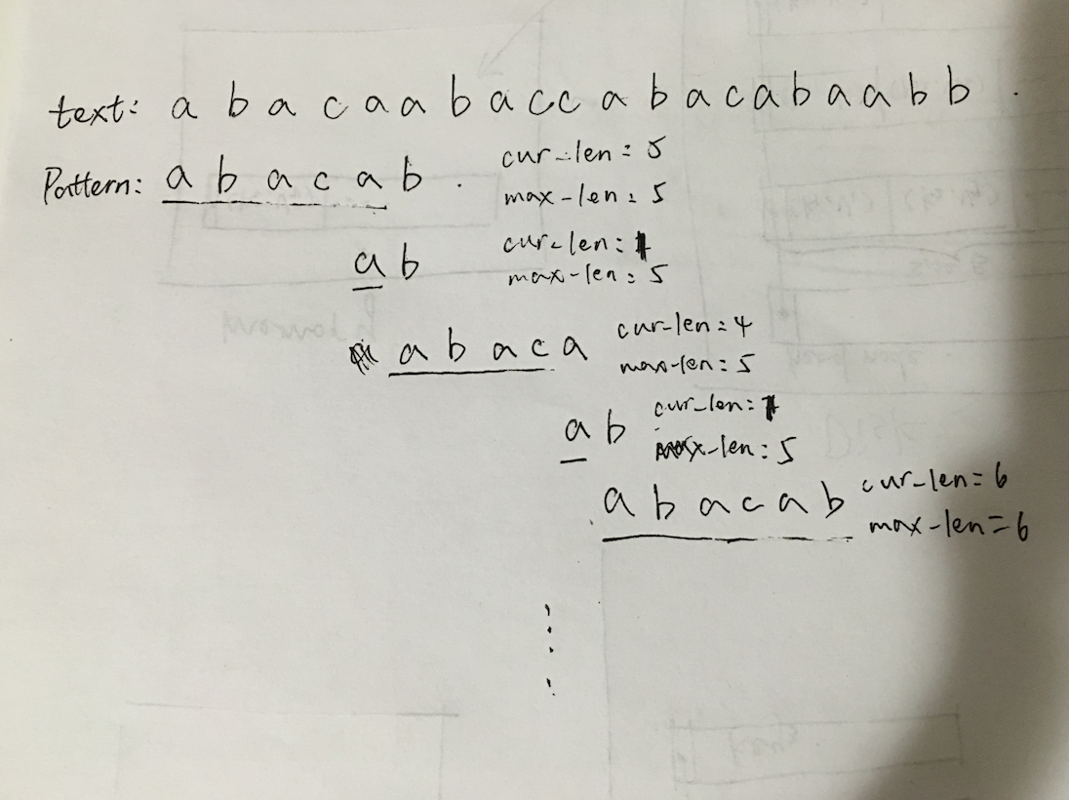

**A-23.2 Search engines need a fast way to detect and ignore stop words, that is, words, such as prepositions, pronouns, and articles, that are very common and carry no meaningful information content. Describe an efficient method for storing and searching a set of stop words in a way that supports stop-word identification in constant time for all constant-length stop words.**

The brute force solution is to compare each letter of the target word with each letter of every words in the stop alphabet. For example, if now we have a word “the”, and the stop word alphabet contains like “a, the, there, than, till…”. We get all the subset in the alphabet with the first letter ‘t’ which are “the, there, than, till”. And then we get all the subset with the second letter ‘h’ from the subset above, so on and so forth. This algorithm is very slow because it compares each letter of the word in the text with each letter of the word in the stop word alphabet.

The main problem of the brute force algorithm is that it has some redundant comparisons. To solve this problem, we can build a trie tree for the stop words, so that it won’t traverse all the stop words with the same letter in the particular place. A compressed trie will be more efficient, for it just traverses the redundant letter once. (ex. the “i” and “d” in “bid” are “redundant” because they signify the same word.)

The insertion and search time of the algorithm would be the height of the tree or say the length of the related stop word.